**CHAPTER-1**

**INTRODUCTION**

**1.1 Introduction**

The "Online Medical Store Management " has been developed to override the problems prevailing in the practicing manual system. This software is supported to eliminate and in some cases reduce the hardships faced by this existing system. Moreover this system is designed for the particular need of the company to carry out operations in a smooth and effective manner.

The application is reduced as much as possible to avoid errors while entering the data. It also provides error message while entering invalid data. No formal knowledge is needed for the user to use this system. Thus by this all it proves it is user-friendly. Medical Store Management System , as described above, can lead to error free, secure, reliable and fast management system. It can assist the user to concentrate on their other activities rather to concentrate on the record keeping. Thus it will help organization in better utilization of resources.

Every organization, whether big or small, has challenges to overcome and managing the information of Stocks, Medical Shop, Sales, Medicine, User. Every Medical Shop Management System has different Medical Shop needs, therefore we design exclusive employee management systems that are adapted to your managerial requirements. This is designed to assist in strategic planning, and will help you ensure that your organization is equipped with the right level of information and details for your future goals. Also, for those busy executive who are always on the go, our systems come with remote access features, which will allow you to manage your workforce anytime, at all times. These systems will ultimately allow you to better manage resources.

**1.2 Scope:**

The software product to be produced is a Medical Store Management System which will automate the major medical store operations. The first subsystem is to keep record of the stock of the medicines available and expiry date of the medicines. The second subsystem is for billing and keep record of the customer. The third subsystem is keep record of the sale and the supplier and keep record of the profits and losses .

The proposed system for “medical shop management system” is computerized. Today is the age of computers. This software project solves all the problems discussed above in the present system. The main objective of developing this project is to save time and money. The proposed system provides the following features on different tasks. All the details related to a medical shop could be finding in one place .Will make the monitoring of medical shop and stock details easy.

**1.3 Purpose**

The objective of Medical Shop Management System providing the medicines to the customers according to their request which contains the type of the medicine and the quality. The manufactures and manufacture the medicine requested and the same will be sent to the dealers. All the records will be saved systematically and not manually through paper work to solve further confusions and to make life easy. Database is cleared yearly or depending on certain span of time. It is an error free system and user friendly. It reduces paper work

**CHAPTER-2**

**LITERATURE SURVEY**

1. Economic Feasibility:

Cost_benefit analysis is used for this feasibility. Also we have to consider about

recurring cost. It includes-

i. Rental purchase of equipment.

ii. Salary of person (who operate this system)

iii. Equipment maintenance.

Thus this system when compare on economical grounds proves to be more cost but

acceptable. Hence we say that it economically feasibile system.

2. Technical Feasibility:

The proposed system requires hardware and software for its implementation. The

computer system with printer is available in the mentioned construction organization. The

computerized system follows all technical parts affected to technical views. The

computerized system does not require any specific type of hardware. No additional

hardware is required by the system. So we say that system is technically feasible.

3. Behavioural Feasibility:

This is dependent upon determining human resources of project. All workers,

who are employed not, dismissed. We suggest that the eligible supervisors will be

employed in the firm as computer operator, after training them. Rest of them will be

given job to other section of department whether the helpers are required.

4. Operational Feasibility:

This study deals with the following issues:

Is there sufficient for the project for the medical shop management and user has been

in planning and development of project. When the proposed system was tested for

above mentioned issues. It was found that result tending towards being positive and

leading the system to make operationally feasible.

**2.1 Existing System**

The Existing system of the medical shop records just goes through maintaining thefiles according to the medicine companies. Like the records of the particular company,product etc. then the records of that each company schemes. The sections are created on thebasis of a company are maintained on separate page, that of shops on the section of shops.

It becomes very tedious job to maintain medicine stock manually.

In the existing system, all the basic information was gathered from manually inspreadsheet format using files.

**2.1.1 Problem Analysis**

* To develop the computerized management system of medical shop from the manualsystem implemented at present.
* To maintain the record of the shop.
* To maintain the information of items being purchased.
* To maintain the records of customers billing and stock

**2.1.2 Limitations of existing system**

* It requires a lot of human time and thus is time consuming.
* The job of maintaining the records manually is very tedious.
* Voluminous data cannot be handled accurately.
* We cannot find a record of particular product, company or bill.
* Outstanding bills cannot be provided at proper time manually because it requires a lotof time.
* In existing system, accuracy is low because of computational errors and inability toprocess some transactions or errors committed due to fatigue in repetitive clericaltasks.To avoid all such problems an existing system requires computerized system

**2.2 Proposed System:**

The proposed system can overcome all the limitations of the existing system. Thesystem provides proper security and reduces the manual work. The proposed system tries toeliminate or reduce these difficulties up to some extent. The Minimize manual data entry

* Better services
* User friendliness and interactive

Minimum time required proposed system will help the user to reduce the workloadand mental conflict. The proposed system helps the user to work user to work user friendlyand he can easily do his jobs without time lagging. It has got following features.

* Ensure data accuracy
* Secure data accuracy
* Proper control of the higher officials
* Minimum time needed for the various processing

**2.3 Feasibility Study**

Feasibility study is a survey of possibility of computerization based on the nextmanagement of objectives related to an analysis of the existing facilities within the company.

The information collection that occurs during preliminary investigation examinessystem feasibility and the like hood that the system will be beneficial to the organization. Inthis system the test, which were carried out for feasibility study were technical feasibility andeconomic feasibility.

**1. Economic Feasibility.**

**2. Behavioural Feasibility.**

**3. Technical Feasibility.**

**4. Operational Feasibility**

**1. Economic Feasibility:**

Cost_benefit analysis is used for this feasibility. Also we have to consider aboutrecurring cost. It includes-

* + 1. Rental purchase of equipment
    2. Salary of person (who operate this system)
    3. Equipment maintenance.

Thus this system when compare on economical grounds proves to be more cost butacceptable. Hence we say that it economically feasibile system.

**2. Technical Feasibility:**

The proposed system requires hardware and software for its implementation. Thecomputer system with printer is available in the mentioned construction organization. Thecomputerized system follows all technical parts affected to technical views. Thecomputerized system does not require any specific type of hardware. No additionalhardware is required by the system. So we say that system is technically feasible.

**3. Behavioural Feasibility:**

This is dependent upon determining human resources of project. All workers,who are employed not, dismissed. We suggest that the eligible supervisors will beemployed in the firm as computer operator, after training them. Rest of them will begiven job to other section of department whether the helpers are required.

**4.Operational Feasibility:**

This study deals with the following issues:Is there sufficient for the project for the medical shop management and user has beenin planning and development of project. When the proposed system was tested forabove mentioned issues. It was found that result tending towards being positive andleading the system to make operationally feasible.

**CHAPTER-3**

**SCOPE OF THE PROJECT**

It may help collecting perfect management in details. In a very short time, the collection will be obvious, simple and sensible. It will help a person to know the management of passed year perfectly and vividly. It also helps in current all works relative to Medical Shop Management System. It will be also reduced the cost of collecting the management & collection procedure will go on smoothly.

Our project aims at Business process automation, i.e. we have tried to computerize various processes of Medical Shop Management System.

In computer system the person has to fill the various forms & number of copies of the forms can be easily generated at a time.

**1.** In computer system, it is not necessary to create the manifest but we can directly print it, which saves our time.

**2.** To assist the staff in capturing the effort spent on their respective working areas.

**3.** To utilize resources in an efficient manner by increasing their productivity through automation.

**4.** The system generates types of information that can be used for various purposes.

**5.** It satisfy the user requirement

**6.** Be easy to understand by the user and operator

**7.** Be easy to operate

**8.** Have a good user interface

**9.** Be expandable

**10**. Delivered on schedule within the budget.

**CHAPTER-4**

**METHODOLOGY**

**4.1 Problem Definition**

Drawbacks of System

1. Time consuming…
2. More expensive…
3. Searching problem…
4. Maintains problem of all registers…
5. Less accuracy…
6. Problem for marking of not normal value…
7. More stationary…
8. Display multiple reports…

**4.2 System Requirement & Specification**

System analysis is a process of gathering and interpreting facts, diagnosis problemsand the information about the Medical Shop Management System to recommendimprovements on the system. It is a problem solving activity that requires intensivecommunication between the system users and system developers. System analysis or study isan important phase of any system development process. The system is viewed as a whole andtraced to the various processes. Such system analysis is concerned with becoming aware ofthe problem, identifying the relevant and decisional variables.

Advantages of computerized system

1. Time saving…
2. Less expensive…
3. Powerful searching…
4. Solve the problem of maintains register…
5. More accuracy…
6. Easy generate report…
7. Not display multiple reports…

**4.2.1 Hardware Requirements**

* Processor: Intel dual core or above
* Processor Speed: 1.2GHZ or above
  + - RAM: 4GB RAM or above
    - Hard Disk: 500GB hard disk or above

**4.2.2 Software Requirements**

* Language: PHP(v.8.1.0)
  + - HTML
    - Bootstrap
* Database: SQL Server
* Operating System: Windows 10/11

**CHAPTER-5**

**SYSTEM DESIGN**

**5.1 Module Of The Software**

* **Login:** Admin can choose his own username and password. After logging into the system, he can provide username and password to other unauthorized users.
* **Master:** Product master contain the name of the product and the rate for each product.Product rate differs for dealer and adhoc sales. Employee master contains the complete details of the employee working in the factory. Dealers master contains the information of the daily dealers.
* **Order:** The order from the dealer is taken through phone and the products, quality is entered by an employee. It will be saved in the database and a crystal report will generated for billing purpose.
* **Manufacturing:** At the end of the today, total number of products to be manufactured report will be sent to the manufacturing department.
* **Stock:** After manufacturing, the products will be sent to the stock. Here we can get the total number of products available.
* **Sales:** This is a type of sale where the dealer or the customer can visit and buy the products normally.
* **Distribution:** Through transportation the products will be distributed to the dealer according to their request.
* **Reports:** Stock reports, shop inventory reports, dealer reports, manufacturer reports, products returned reports, refunded amount, paid amount reports can be generated

**5.2 Entity Relationship Diagram**

Entity Relationship DiagramER-Diagram is designed tool. It is graphical representation of database system &entity described by its various attributes. Two entity related with one another. If there issome association present between them this relationship is shown with help of diagram.

**\*Shape Of Entity Relationship Diagram\***

This Represent Entity Set

ER Diagram of Medical Store Management:

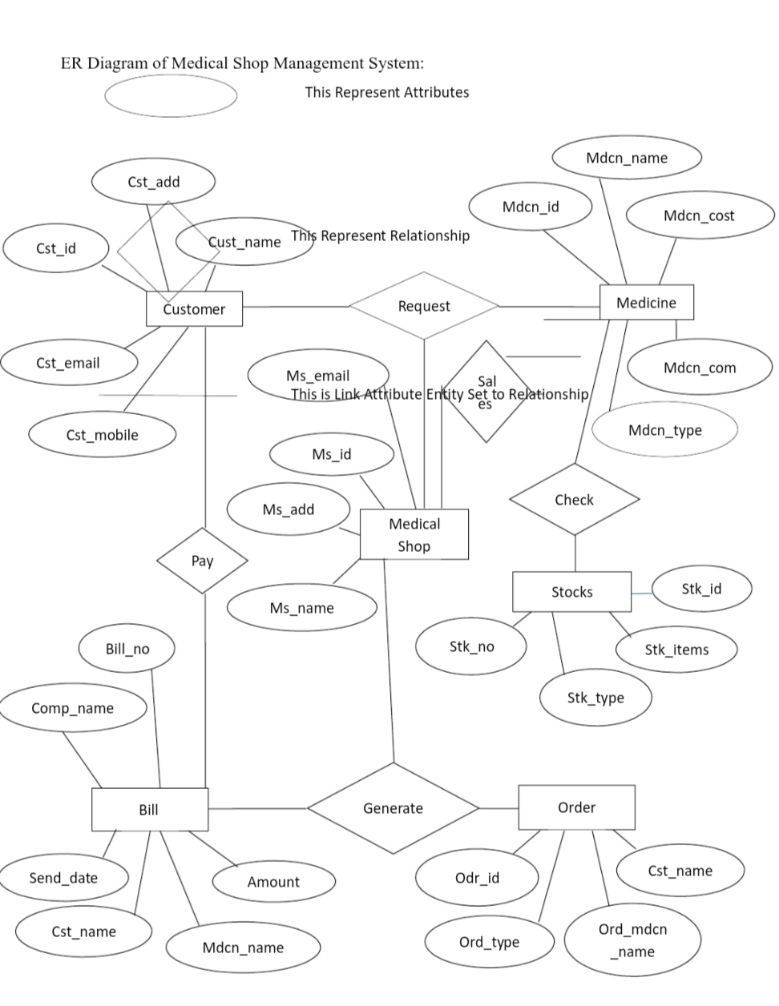

Fig.1 ER Diagram

**5.3 Data Flow Diagram**

**1)Zero Level DFD**

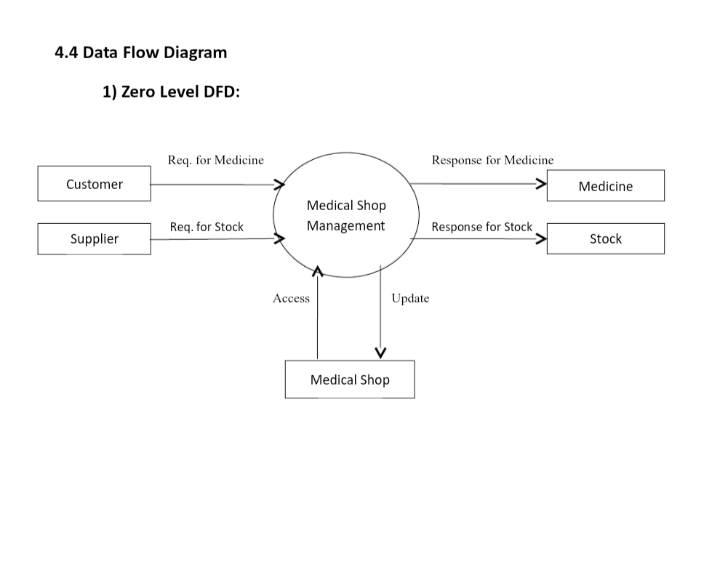

Fig.2 Zero Level DFD

**2) First Level DFD:**

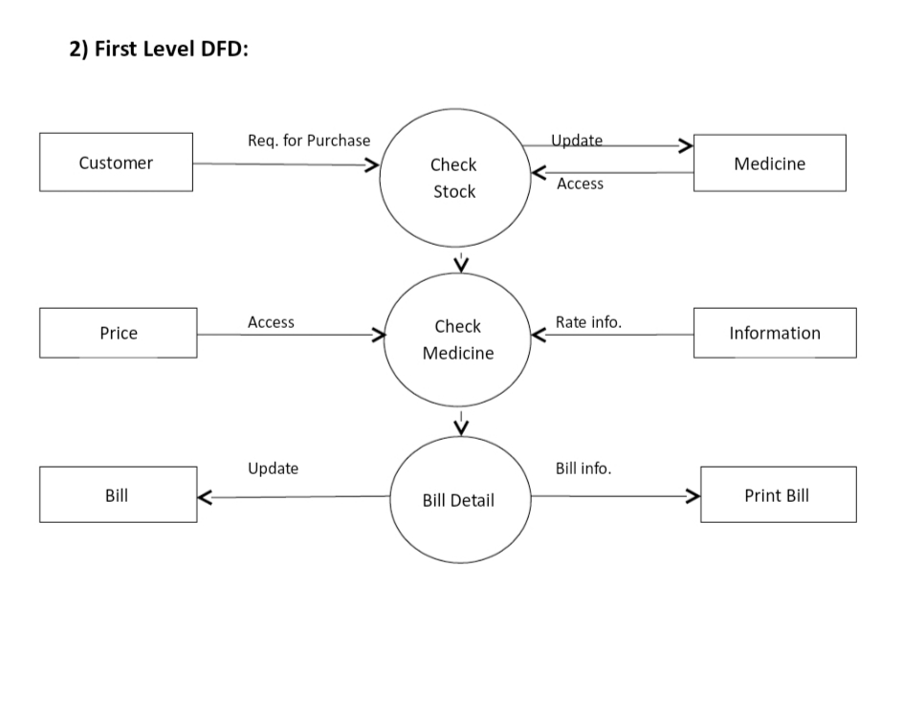

Fig.3 First Level DFD

**3) Second Level DFD:**

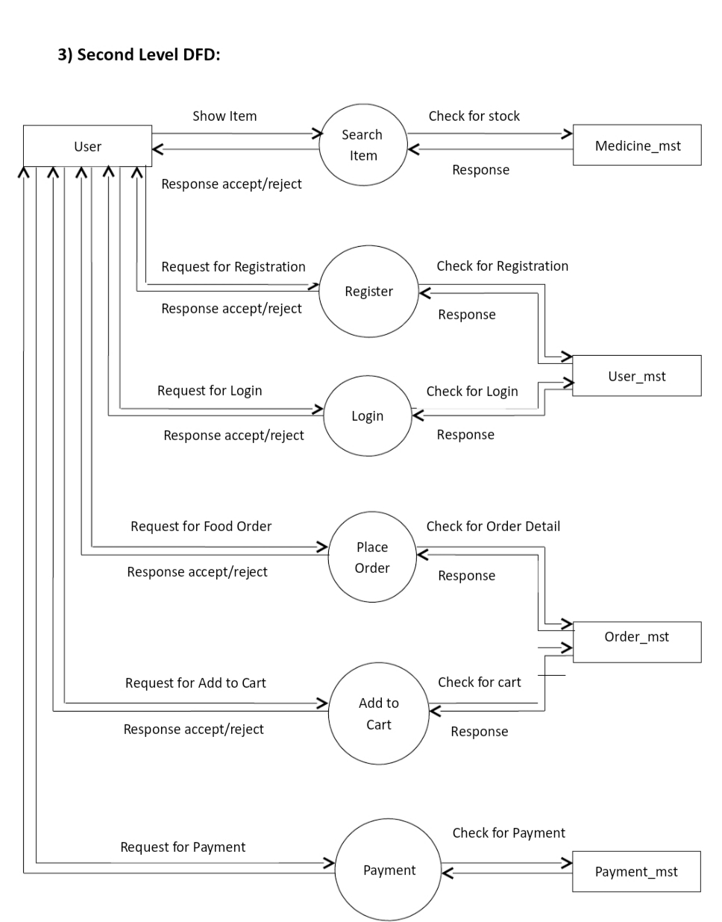

Fig.4 Second Level DFD

**5.4 Use Case Diagrams**

**Use Case Diagram for Distributor System:**

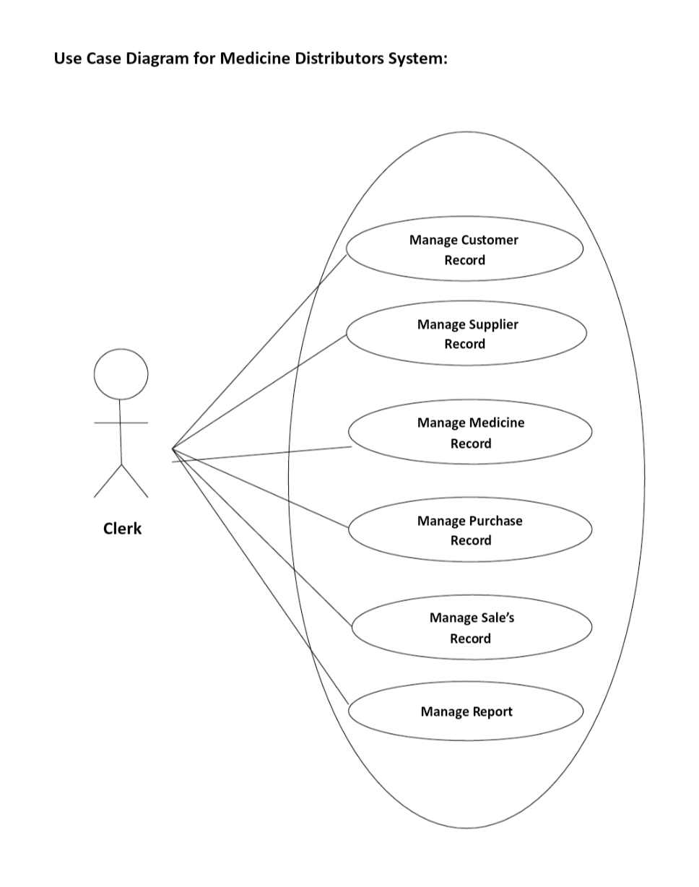

Admin

Fig.5 Use Case Diagram for Distributor System

**Use Case Diagram for Customer Subsystem:**

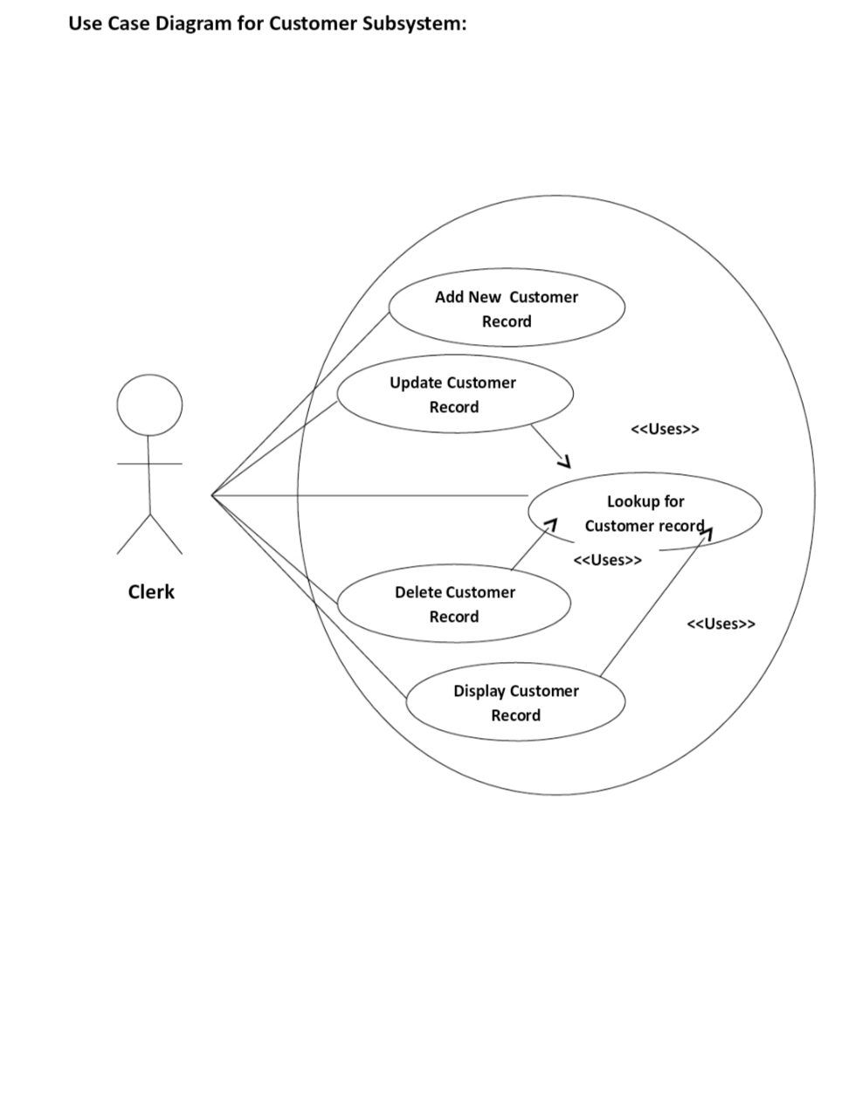

Admin

Fig.6 Use Case Diagram for Customer Subsystem

**Use Case Diagram for Medicine Subsystem:**

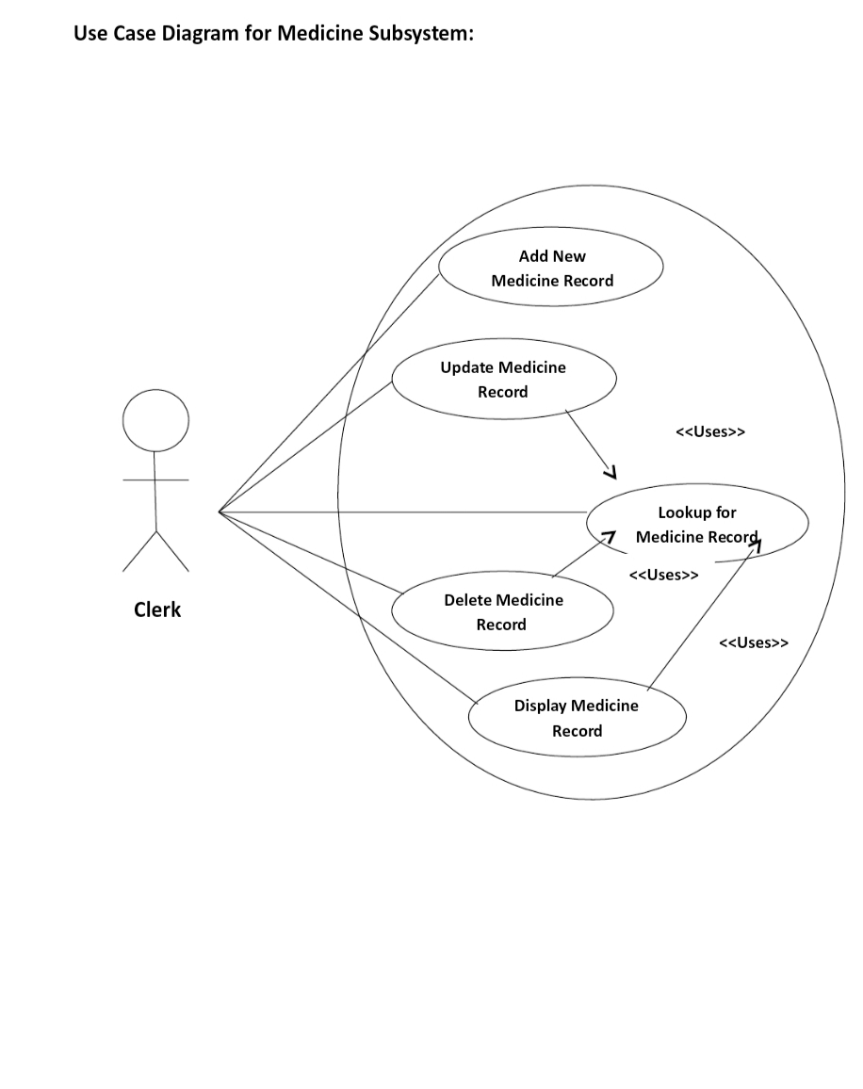

Admin

Fig.7 Use Case Diagram for Medicine Subsystem

**Use Case Diagram for Purchase Order Subsystem:**

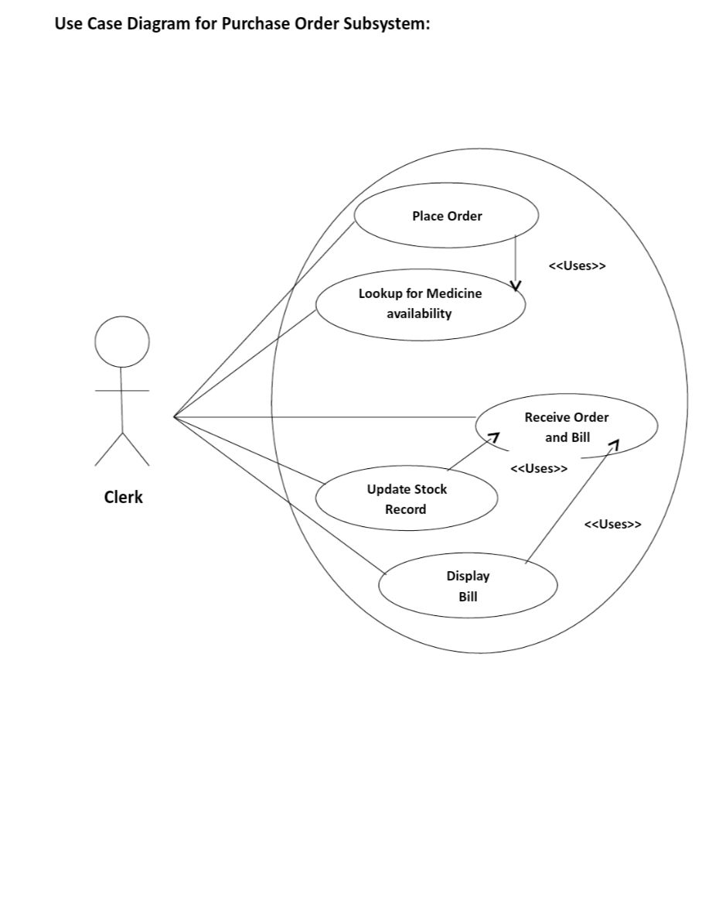

Admin

Fig.8 Use Case Diagram for Purchase Order Subsystem

**Use Case Diagram for Medicine Report Subsystem:**

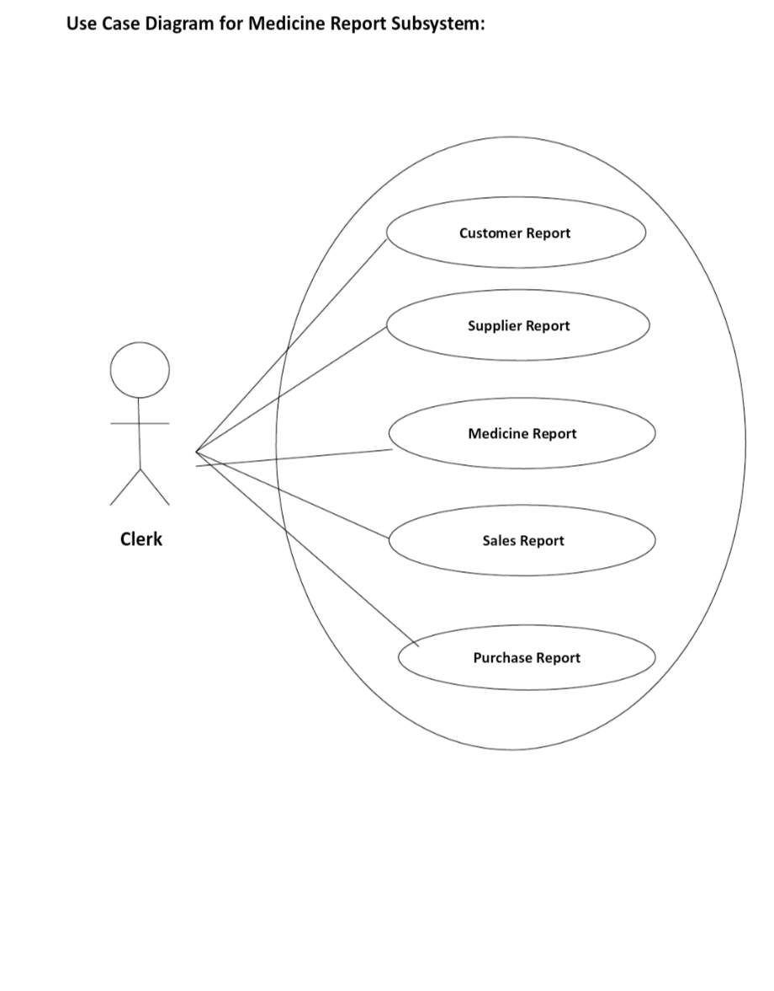

Admin

Fig.9 Use Case Diagram for Medicine Report Subsystem

**5.5 Class Diagram**

The UML activity diagram supplements the user case by providing a graphical representation of the flow of interaction within a specific scenario similar to the flow chart, an activity diagram uses rounded rectangles to imply a specific system function, arrow to represent flow through the system, Decision diamonds to depict a branching decision & solid horizontal lines to indicate that parallel activities occurs

* **Symbol used in Class Diagram:**

Name of class

Attributes

Methods

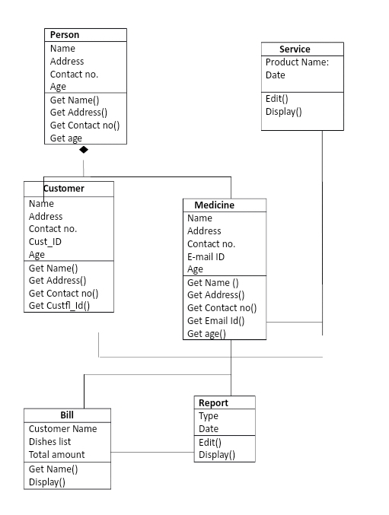

Fig.10 Class Diagram

**5.6 Sequence Diagram**

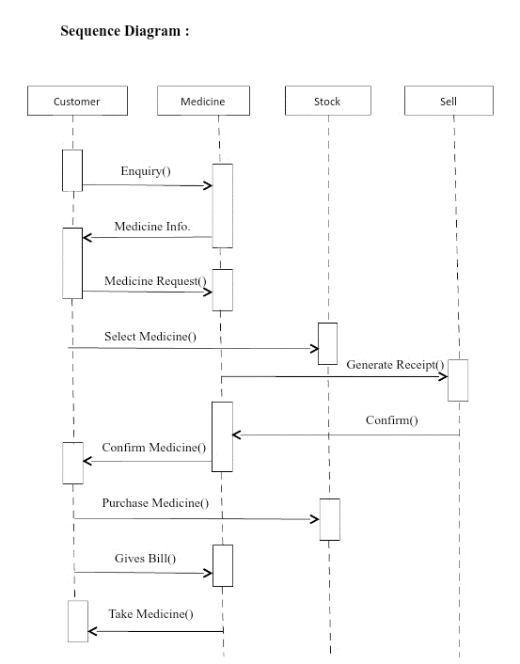

Fig.11 Sequence Diagram

**Report for Service:**

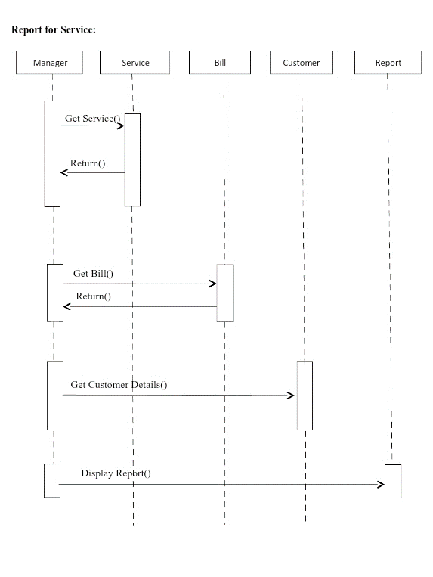

Fig.12 Sequence Diagram for Report Service

**CHAPTER-6**

**RESULTS AND APPLICATIONS**

**6.1 Source Code**

<?php

session_start();

include("includes/db.php");

include("includes/header.php");

include("functions/functions.php");

include("includes/main.php");

?>

<!-- Cover -->

<main>

<div class="hero">

<a href="shop.php" class="btn1">View all products

</a>

</div>

<!-- Main -->

<div class="wrapper">

<h1>BEST MEDICINE AND ALL TYPES MEDICINE<h1>

</div>

<div id="content" class="container"><!-- container Starts -->

<div class="row"><!-- row Starts -->

<?php

getPro();

?>

</div><!-- row Ends -->

</div><!-- container Ends -->

<!-- FOOTER -->

<footer class="page-footer">

<div class="footer-nav">

<div class="container clearfix">

<div class="footer-nav__col footer-nav__col--info">

<div class="footer-nav__heading">Information</div>

<ul class="footer-nav__list">

<li class="footer-nav__item">

<a href="#" class="footer-nav__link">The brand</a>

</li>

<li class="footer-nav__item">

<a href="#" class="footer-nav__link">Local stores</a>

</li>

<li class="footer-nav__item">

<a href="#" class="footer-nav__link">Customer service</a>

</li>

<li class="footer-nav__item">

<a href="#" class="footer-nav__link">Privacy &amp; cookies</a>

</li>

<li class="footer-nav__item">

<a href="#" class="footer-nav__link">Site map</a>

</li>

</ul>

</div>

<div class="footer-nav__col footer-nav__col--whybuy">

<div class="footer-nav__heading">Why buy from us</div>

<ul class="footer-nav__list">

<li class="footer-nav__item">

<a href="#" class="footer-nav__link">Shipping &amp; returns</a>

</li>

<li class="footer-nav__item">

<a href="#" class="footer-nav__link">Secure shipping</a>

</li>

<li class="footer-nav__item">

<a href="#" class="footer-nav__link">Testimonials</a>

</li>

<li class="footer-nav__item">

<a href="#" class="footer-nav__link">Award winning</a>

</li>

<li class="footer-nav__item">

<a href="#" class="footer-nav__link">Ethical trading</a>

</li>

</ul>

</div>

<div class="footer-nav__col footer-nav__col--account">

<div class="footer-nav__heading">Your account</div>

<ul class="footer-nav__list">

<li class="footer-nav__item">

<a href="#" class="footer-nav__link">Sign in</a>

</li>

<li class="footer-nav__item">

<a href="#" class="footer-nav__link">Register</a>

</li>

<li class="footer-nav__item">

<a href="#" class="footer-nav__link">View cart</a>

</li>

<li class="footer-nav__item">

<a href="#" class="footer-nav__link">View your lookbook</a>

</li>

<li class="footer-nav__item">

<a href="#" class="footer-nav__link">Track an order</a>

</li>

<li class="footer-nav__item">

<a href="#" class="footer-nav__link">Update information</a>

</li>

</ul>

</div>

<div class="footer-nav__col footer-nav__col--contacts">

<div class="footer-nav__heading">Contact details</div>

<address class="address">

Shelar Nitin <br>

Labade Pradip<br>

Kakade Dinesh<br>

Nibhore Swapnil<br>

Indira Gandhi Polytechnic, Belwndi(Suagar)

</address>

<div class="phone">

Telephone:

<a class="phone__number" href="tel:0123456789">0123-456-789</a>

</div>

<div class="email">

Email:

<a href="mailto:support@yourwebsite.com" class="email__addr">support@yourwebsite.com</a>

</div>

</div>

</div>

</div>

<div class="page-footer__subline">

<div class="container clearfix">

<div class="copyright">

&copy; <?php echo date("Y");?> @2022 NPD Medicia&trade;

</div>

<div class="developer">

Developed by<br>

Labade.P.A, Shelar.N.D, Kakde.D.D, Nimbhore.S.S

</div>

</div>

</div>

</footer>

</body>

</html>

**6.2 Output**

* Home Page

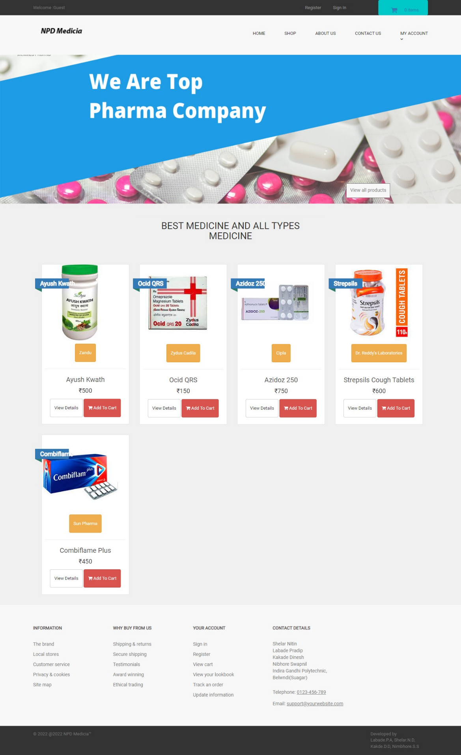

Fig,13 Home Page

* Login Page

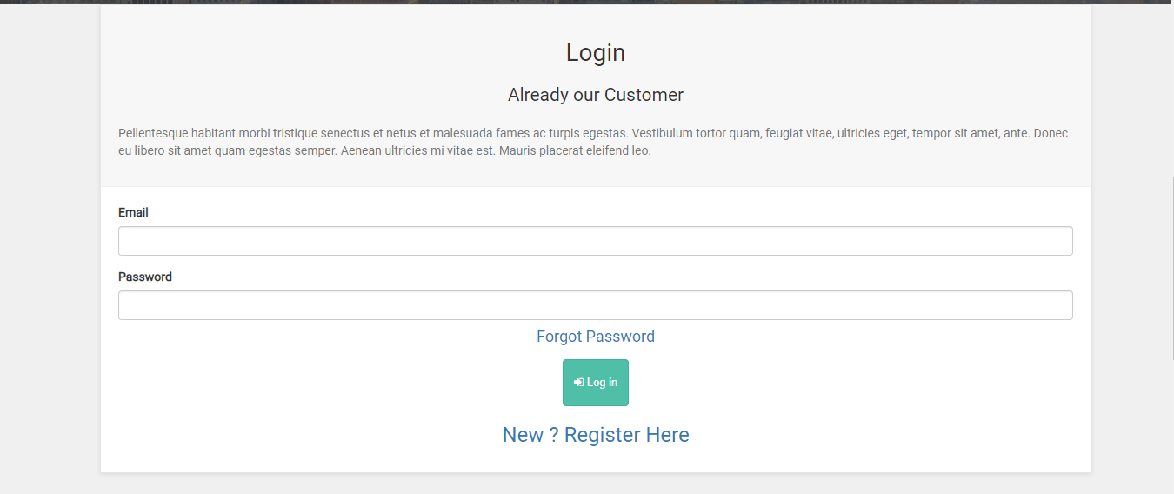

Fig.14 Login Page

* Registration Page

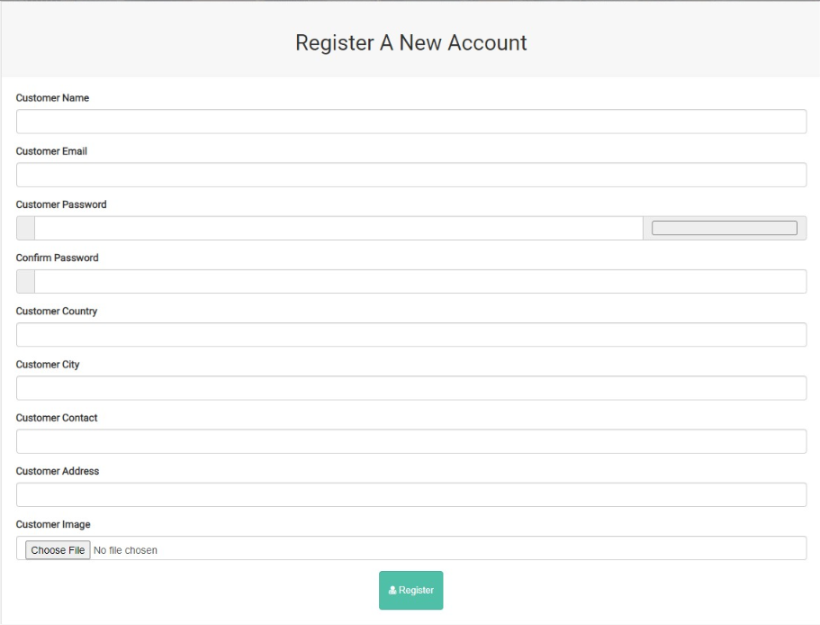

Fig.15 Registration Page

* Product View

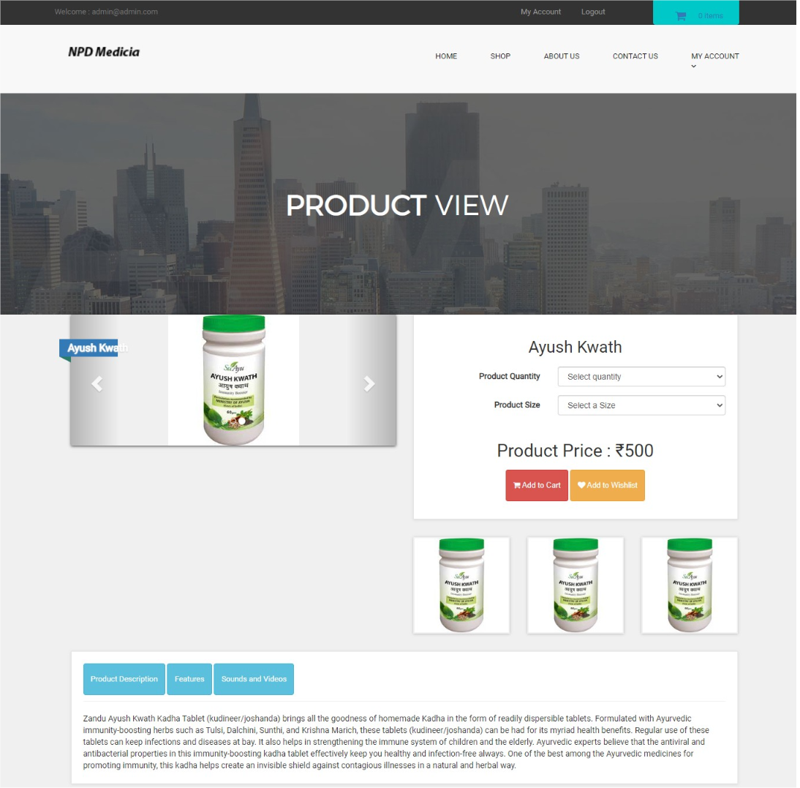

Fig.16 Product View

* Shop Cart

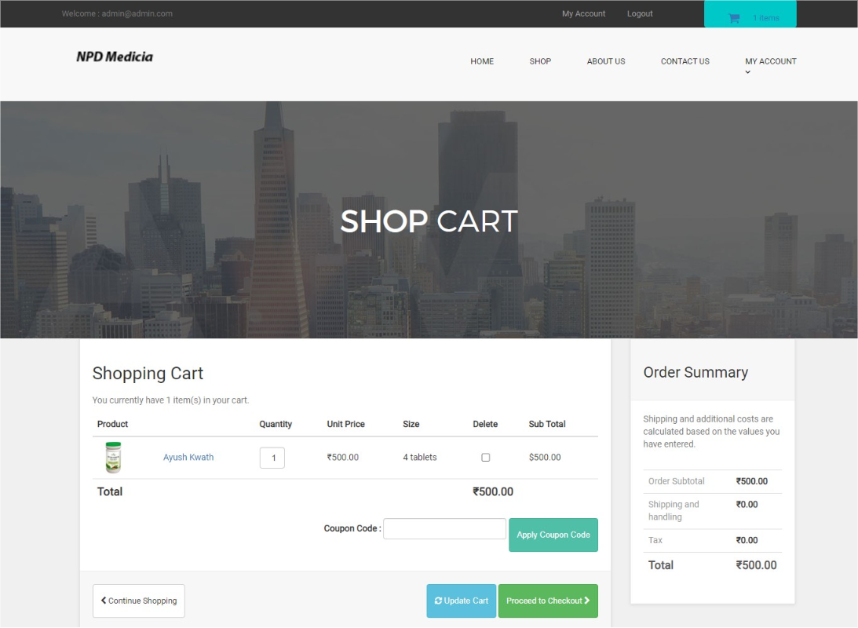

Fig.17 Shop Cart

* Checkout

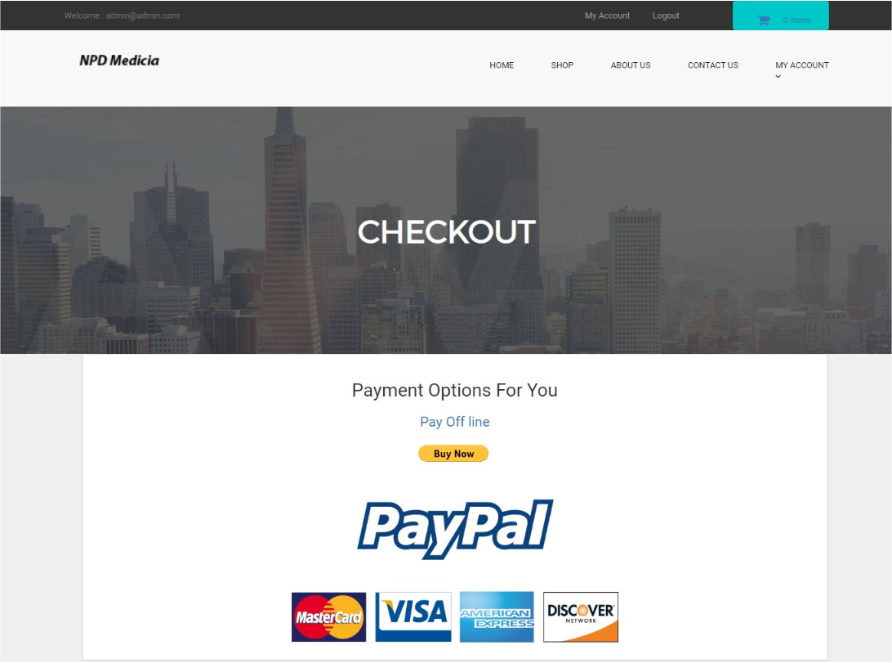

Fig.18 Checkout

* Order Page

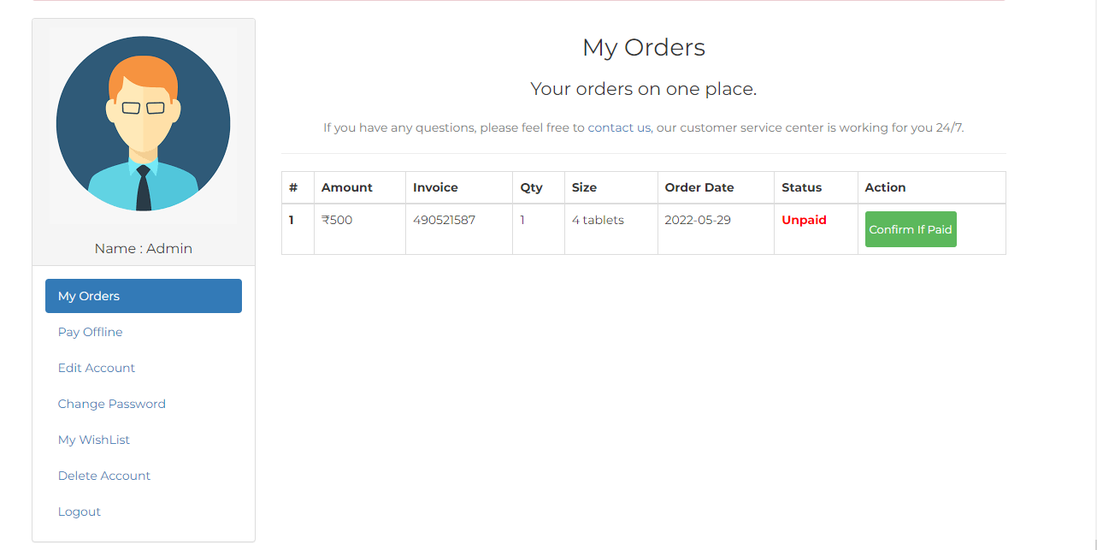

Fig.19 Order Page

* Payment Page

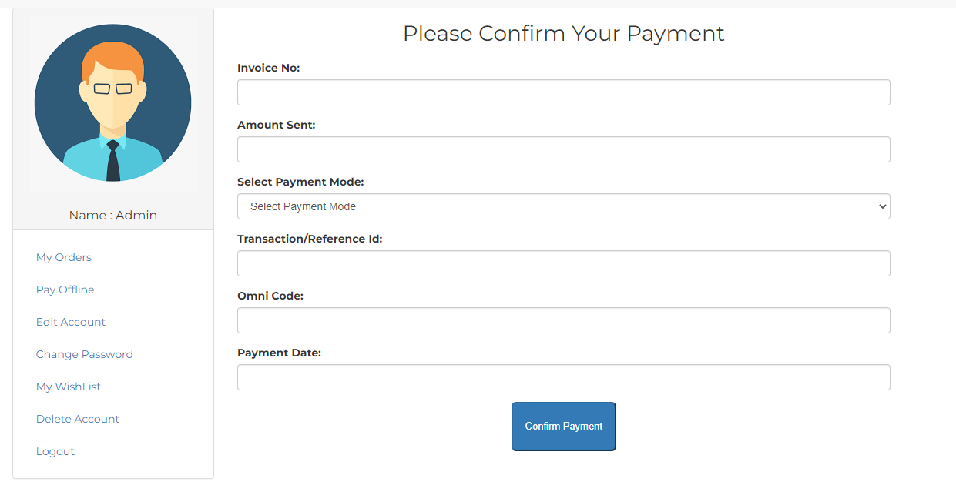

Fig.20 Payment Page

* Admin Login

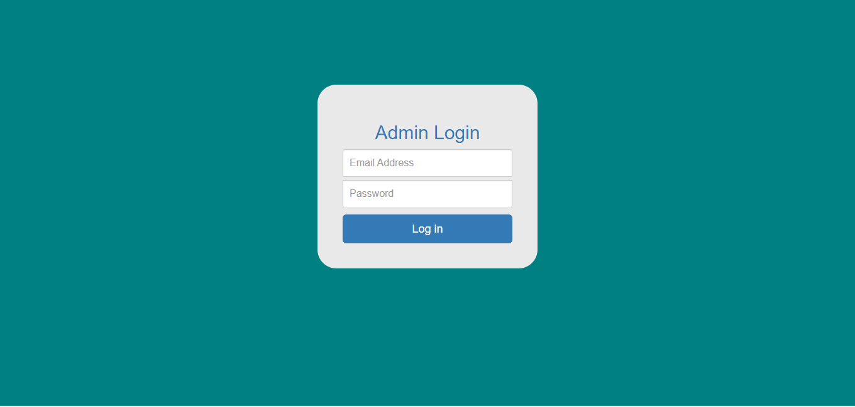

Fig.21 Administration Page

* Administration Panel

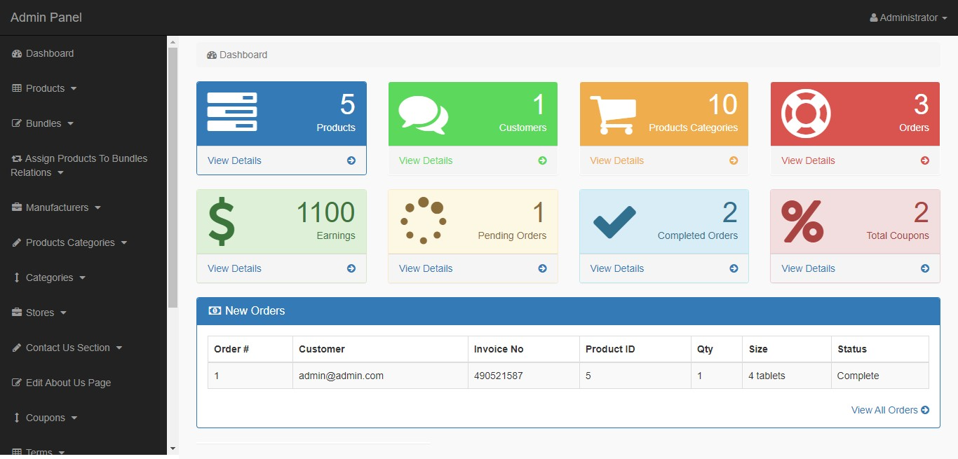

Fig.22 Administration Panel Page

**CHAPTER-7**

**TESTING REPORT**

* Test Cases for Admin Registration

|  |  |  |  |  |  |  |  |
| --- | --- | --- | --- | --- | --- | --- | --- |
| Sr.no | Objective | Pre- condition | Steps | Input Data | Expected result | Actual  result | Status |
| 1. | To Check Validity Admin Registration on form | Admin registration on Page should be open | 1.Click on new admin Registration.  2.Fill the proper information  3.Click on register button. | Enter the Proper and correct data in TextBox. | Show message record inserted successful. | Message is Displayed | Pass |
| 2. | To check Validity of remove option from student menu | Login Sucessful and home page should be open | 1.click on  Online medical store Registration  Panel | Enter the username and Password and click delete Button. | Show message record delete successfully. | Record is deleted and displays the message. | Pass |

* Test Cases for Admin Login

|  |  |  |  |  |  |  |  |
| --- | --- | --- | --- | --- | --- | --- | --- |
| Sr.no | Objective | Pre- condition | Steps | Input Data | Expected result | Actual  result | Status |
| 1. | When enter valid admin Username and Password. | Login Page should be open | 1.Enter the correct Username.  2.Entee the Password.  3.Click on Login Button. | Username=admin.  Password=admin. | Display message *Login Suceesful* | Displayed the message *Login Sucessful* | Pass |
| 2. | When enter invalid admin username and Password | Login page should be open | Enter wrong username and Password | Username=admin123  And  Password=admin123. | Show message *something get Wrong please check it....* | Message is Display *something get wrong please check it…* | Pass |

* Test Cases for Purchase Order

|  |  |  |  |  |  |  |
| --- | --- | --- | --- | --- | --- | --- |
| Test case ID | Test Scenario | Pre-conditions | Test Steps | Exepted Result | Actual Result | Status |
| TC_1 | Verify login and Password |  | Enter the valid Username and password successfully | Login mus be successful | Login successfully done | pass |
| TC_2 | Create a new purchase order | Login Successful | 1.Click new order in left most part of Dashboard.  2.Enter the vender account and site name .  3.Save the deatails after entering mandatory filds. | Purchase order must be successful | Purchase order creation successfully done | Pass |
| TC_3 | Search item number | Login Successful | Enter the associated item number for vendor . | Enter the associated item number for vendor . | Item number must added sucessfully | Pass |
| TC_4 | Save and confirm Purchase order | Login Successful | Click save button and purchase confirm order | Click save button and purchase confirm order | Purchase order must creation successfully done | Pass |

* Test Cases for Administration Login

|  |  |  |  |  |  |  |  |
| --- | --- | --- | --- | --- | --- | --- | --- |
| Sr.no | Objective | Pre- condition | Steps | Input Data | Expected result | Actual  result | Status |
| 1. | When enter valid admin Username and Password. | Login Page should be open | 1.Enter the correct Username.  2.Entee the Password.  3.Click on Login Button. | Username=admin.  Password=admin. | Display message *Login Suceesful* | Displayed the message *Login Sucessful* | Pass |
| 2. | When enter invalid admin username and Password | Login page should be open | Enter wrong username and Password | Username=admin123  And  Password=admin123. | Show message *something get Wrong please check it....* | Message is Display *something get wrong please check it…* | Pass |

**CHAPTER-8**

**CONCLUSION AND FUTURE SCOPE**

**8.1 Conclusion**

The management system employs strict measures to protect the users from intruders or outsiders. One of such measures is the inability of a prospective user to register on the platform without the permission of the administrators. To register on the platform, all necessary details such as: name, address, tax documents, payment methods, and relevant licenses are sent to the administrator for proper verification. When the authenticity of these documents have been proven, the administrator then creates the account for the customer and forwards the details for login to the management system. Also, since the drugs purchased through the platform are for pharmaceutical purposes, and as such, are ordered in bulk, if a small quantity of drugs is ordered, the administrators are notified, who then confirms the order from the pharmacy to ensure that an intruder has not obtained their login details.

**8.2 Future Scope**

In a nutshell, it can be summarized that the future scope of the project circles around maintaining information regarding

* We can add printer in future.
* We can give more advance software for Medical Shop Management System including more facilities
* We will host the platform on online servers to make it accessible worldwide
* Integrate multiple load balancers to distribute the loads of the system
* Create the master and slave database structure to reduce the overload of the database queries
* Implement the backup mechanism for taking backup of codebase and database on regular basis on different servers.

The above mentioned points are the enhancements which can be done to increase the applicability and usage of this project. Here we can maintain the records of Customer and Medicine. Also, as it can be seen that now-a-days the players are versatile, i.e. so there is a scope for introducing a method to maintain the Medical Shop Management System. Enhancements can be done to maintain all the Customer, Medicine, Medicine Comapny, Medicine Stock, Sells.

We have left all the options open so that if there is any other future requirement in the system by the user for the enhancement of the system then it is possible to implement them.In the last we would like to thanks all the persons involved in the development of the system directly or indirectly. We hope that the project will serve its purpose for which it is develop there by underlining success of process.

**CHAPTER-9**

**REFERENCE**